Photress

Version <1.1>

Revision History

|  |  |  |  |
| --- | --- | --- | --- |
| **Date** | **Version** | **Description** | **Author** |
| 17.10.2013 | <1.0> | First version of user registration | Benny Görzig |
|  |  |  |  |
|  |  |  |  |
|  |  |  |  |

Table of Contents

1. User Registration 4

1.1 Brief Description 4

2. Flow of Events 5

3. Special Requirements 5

4. Preconditions 5

5. Postconditions 5

6. Extension Points 5

7. Mockup 6

8. Narration 7

# User Registration

## Brief Description

The Use Case “User Registration” is specifically for guests. Guests will be able to create accounts for using the provided services of Photress.

# Flow of Events

You will find the latest version of the activity diagram under the following link:

<http://photress.it.dh-karlsruhe.de/?p=46>

# Special Requirements

N.a.

# Preconditions

The user has to have a valid e-mail-address to activate his account. This address must not be linked to an already registered or a non-active account.

# Postconditions

A new account has been registered and an activation mail has been sent out to the given e-mail-address.

The status of this account is set to non-active.

# Extension Points

N.a.

# Mockup

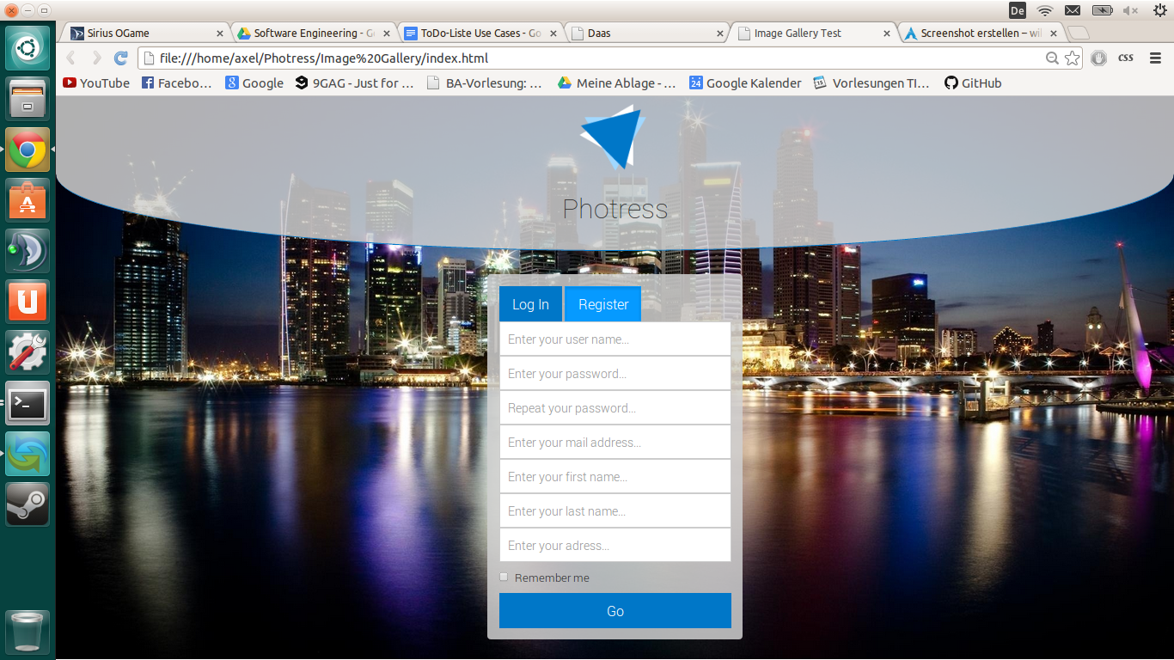

# Narration

Feature: user registration on Photress

As an unregistered user

I want to register myself

So I can use the awesome services of Photress

Scenario: register myself correctly

Given I am on the login/register page

And I click on register

And I enter "Adracus" as user name

And I enter "test123" as password

And I enter "test123" as repeated password

And I enter "adracus@gmail" as mail address

And I enter "Axel" as first name

And I enter "Christ" as last name

And I enter "Germany, Karlsruhe" as address

And I press "Go"

Then I should be redirected to the login-success page

And I should see "A verification mail to your account has been sent"

Scenario: register myself incorrectly

Given I am on the login/register page

And I click on register

And I enter "Adracus" as user name

And I press "Go"

Then I should stay on the login/register page

And I should see the missing fields highlighted as missing